

School of Engineering & Technology
Computer Science Department

A Project report on
“Lunar Lander using OpenAI v3 – Continuous Action Space”

Submitted By:
Vedant Malhotra (23CSU339)
Dhyanesh Sharma (23CSU100)
Vidyansh Gaur (23CSU342)

Section: AI & ML Sec – D, Grp - 7
Date: 17 November 2025

Acknowledgment

We extend our sincere gratitude to our teacher Jyoti Yadav ma’am, for providing us with this opportunity and guiding us every step of the way. Her support and mentorship have been invaluable to the success of our Reinforcement Learning project.

Index
- Introduction
  - Overview
  - Purpose
  - Scope

2. Deep Deterministic Policy Gradient (DDPG) Algorithm
3. Project Structure
  - Core Code Files
- ddpg_agent.py
- train_ddpg.py
- visualize_ddpg.py
- LunarLander_DDPG_Analysis.ipynb
3.2 Saved Model Files
- ddpg_actor.pth
- ddpg_critic.pth
3.3 Training Log Files
- ddpg_training_rewards.txt
- ddpg_training_data.json
4.Environment Description
4.1 Imports and Definitions
4.2 The Environment Class
  - Reset Function
4.4 Step Function
4.5 Visualisation Components

5. Training the DDPG Agent
6. Hyperparameters
7.Results
7.1 Reward Curve
7.2 Landing Stability
7.3 Visual Output
8.Discussion
8.1 Behaviour of the Agent
8.2 Training Challenges
8.3 Future Improvements
9.Conclusion
10.References

1. Introduction
Overview
This project focuses on teaching an autonomous agent to safely land a spacecraft in the LunarLanderContinuous-v3 environment using Reinforcement Learning. The lander must control two continuous thrusters (main vertical thrust and lateral side thrust) to reach the landing pad without crashing.Since the action space is continuous, traditional discrete-action algorithms are not suitable.
To solve this, the project uses the Deep Deterministic Policy Gradient (DDPG) algorithm, which combines deep neural networks with an actor–critic architecture to handle continuous control tasks.
The agent interacts with the environment, receives rewards based on its behaviour, and improves its landing performance over time. Along the way, several files are generated such as model weights (.pth), reward logs (.txt), and detailed stepwise data (.json) that help in analysing learning progression.

Purpose
The main purpose of this project is to design, train, and evaluate an intelligent control system capable of performing smooth and stable moon landings. Specifically, the project aims to:
- Train a reinforcement learning agent using DDPG for continuous control.
- Analyse the behaviour of the agent using stepwise data such as velocity, thrust, angle, and position.
- Save the training progress, including rewards and episode-wise statistics.
- Visualise and replay the trained model using simulation to verify safe landing.
- Provide insights into how continuous RL algorithms learn complex control strategies.
This project also helps in understanding how actor–critic methods function and how deep neural networks can approximate policy and value functions.

Scope
The scope of this project includes the full pipeline of reinforcement learning training and analysis:
- Implementing the DDPG algorithm using Python and PyTorch.
- Training the agent for 1500 episodes in LunarLanderContinuous-v3.
- Recording training data in:
  - ddpg_training_rewards.txt (episode-level rewards)
  - ddpg_training_data.json (step-by-step thrust, velocity, angle, position)
- Saving model parameters in:
  - ddpg_actor.pth
  - ddpg_critic.pth
- Analysing performance using Jupyter Notebook visualisations.
- Running inference using visualize_ddpg.py to watch the trained lander.
- Observing landing success and agent behaviour after training.

2. Deep Deterministic Policy Gradient (DDPG) Algorithm

The deep deterministic policy gradient (DDPG) algorithm is an off-policy actor-critic method for environments with a continuous action-space. A DDPG agent learns a deterministic policy while also using a Q-value function critic to estimate the value of the optimal policy. It features a target actor and critic as well as an experience buffer. DDPG agents support offline training (training from saved data, without an environment).

DDPG uses two neural networks for both the actor and the critic (main and target versions), making a total of four networks:
- Actor Network
Learns a deterministic policy:
It outputs a continuous action (main thrust & side thrust) based on the current state.
- Critic Network
Estimates the Q-value of a given state–action pair.
This helps the actor decide which actions lead to higher long-term rewards.
- Target Actor and Target Critic Networks
These are slowly updated versions of the main networks.
They help stabilize training by reducing oscillations and divergence.

Working of the DDPG Algorithm
DDPG follows this sequence:
1. Take Action
The actor produces an action based on the current state, and exploration noise is added during training:
- Vertical thrust (continuous value between –1 to 1)
- Side thrust (continuous value between –1 to 1)
2. Observe Next State and Reward
The environment returns:
- next state
- reward
- whether the episode ended
3. Store Experience in Replay Buffer
Each transition
(state, action, reward, next state, done)
is saved in the replay memory.
4. Sample a Mini batch
Random mini batches reduce correlation between consecutive experiences.
This stabilises learning.
5. Critic Update
The critic learns the Q-value by comparing:
- the predicted Q-value
- the target Q-value using next state and target actor’s action
6. Actor Update
The actor is updated using the gradient of the critic’s output with respect to the actor’s actions.
This pushes the actor towards actions that produce higher Q-values.
7. Soft Target Update
Target networks are slowly updated:
target_param = τ * param + (1 − τ) * target_param
This prevents sudden changes and keeps training stable.

3. Project Structure
This section outlines the complete structure of our Lunar Lander Reinforcement Learning project, including the DDPG agent architecture, training pipeline, hyperparameters, and simulation environment. It provides a clear breakdown of how the model was developed, trained, evaluated, and visualized to achieve autonomous soft-landing performance.
3.1 Core Code Files
ddpg_agent.py
import torch
import torch.nn as nn
import torch.optim as optim
import numpy as np
import random
from collections import deque

STATE_DIM = 8
ACTION_DIM = 2
HIDDEN = 256

class Actor(nn.Module):
def __init__(self):
super().__init__()
self.net = nn.Sequential(
nn.Linear(STATE_DIM, HIDDEN),
nn.ReLU(),
nn.Linear(HIDDEN, HIDDEN),
nn.ReLU(),
nn.Linear(HIDDEN, ACTION_DIM),
nn.Tanh()
)

def forward(self, x):
return self.net(x)

class Critic(nn.Module):
def __init__(self):
super().__init__()
self.net = nn.Sequential(
nn.Linear(STATE_DIM + ACTION_DIM, HIDDEN),
nn.ReLU(),
nn.Linear(HIDDEN, HIDDEN),
nn.ReLU(),
nn.Linear(HIDDEN, 1)
)

def forward(self, s, a):
x = torch.cat([s, a], dim=1)
return self.net(x)

class ReplayBuffer:
def __init__(self, max_size=200000):
self.buffer = deque(maxlen=max_size)

def add(self, s, a, r, s2, done):
self.buffer.append((s, a, r, s2, done))

def sample(self, batch_size):
batch = random.sample(self.buffer, batch_size)
s, a, r, s2, d = zip(*batch)
return (np.array(s), np.array(a), np.array(r), np.array(s2), np.array(d))

class DDPGAgent:
def __init__(self, gamma=0.99, tau=0.005, actor_lr=1e-4, critic_lr=1e-3):
self.gamma = gamma
self.tau = tau

self.actor = Actor()
self.critic = Critic()

self.actor_target = Actor()
self.critic_target = Critic()

self.actor_target.load_state_dict(self.actor.state_dict())
self.critic_target.load_state_dict(self.critic.state_dict())

self.actor_optimizer = optim.Adam(self.actor.parameters(), lr=actor_lr)
self.critic_optimizer = optim.Adam(self.critic.parameters(), lr=critic_lr)

self.replay = ReplayBuffer()
self.batch_size = 256

def select_action(self, state, noise=0.1):
state = torch.FloatTensor(state).unsqueeze(0)
action = self.actor(state).cpu().detach().numpy()[0]
action += np.random.normal(0, noise, size=ACTION_DIM)
return np.clip(action, -1, 1)

def train(self):
if len(self.replay.buffer) < self.batch_size:
return

s, a, r, s2, d = self.replay.sample(self.batch_size)
s = torch.FloatTensor(s)
a = torch.FloatTensor(a)
r = torch.FloatTensor(r).unsqueeze(1)
s2 = torch.FloatTensor(s2)
d = torch.FloatTensor(d).unsqueeze(1)

# Critic loss
with torch.no_grad():
target_actions = self.actor_target(s2)
target_q = self.critic_target(s2, target_actions)
y = r + self.gamma * (1 - d) * target_q

q = self.critic(s, a)
critic_loss = nn.MSELoss()(q, y)

self.critic_optimizer.zero_grad()
critic_loss.backward()
self.critic_optimizer.step()

# Actor loss
actor_loss = -self.critic(s, self.actor(s)).mean()

self.actor_optimizer.zero_grad()
actor_loss.backward()
self.actor_optimizer.step()

# Soft update
for param, target_param in zip(self.actor.parameters(), self.actor_target.parameters()):
target_param.data.copy_(self.tau * param.data + (1 - self.tau) * target_param.data)

for param, target_param in zip(self.critic.parameters(), self.critic_target.parameters()):
target_param.data.copy_(self.tau * param.data + (1 - self.tau) * target_param.data)

This file contains the complete implementation of the Deep Deterministic Policy Gradient (DDPG) agent.
It includes:
- The Actor neural network for selecting continuous thrust values.
- The Critic neural network for evaluating the chosen actions.
- The Replay Buffer used for storing past experiences.
- The training function that updates both networks using sampled experience batches.
This file defines the learning behaviour of the agent and forms the core of the entire reinforcement learning process.

train_ddpg.py
import gymnasium as gym
import torch
from ddpg_agent import DDPGAgent
import datetime
import os
import json
import numpy as np

EPISODES = 1500
MAX_STEPS = 900
REWARD_LOG_FILE = "ddpg_training_rewards.txt"
TRAINING_DATA_FILE = "ddpg_training_data.json"

print("========Training started========")
env = gym.make("LunarLanderContinuous-v3")
agent = DDPGAgent() # make sure agent has proper hidden layers (256x2 recommended)

# Prepare text file heading with timestamp
timestamp = datetime.datetime.now().strftime("%Y-%m-%d %H:%M:%S")
header = f"\n===== Training Session at {timestamp} =====\n"
with open(REWARD_LOG_FILE, "a") as f:
f.write(header)

# Container for step-wise data
all_episodes_data = []

for ep in range(EPISODES):
state, _ = env.reset()
total_reward = 0

# Step-wise lists
main_thrusts = []
side_thrusts = []
velocity_x = []
velocity_y = []
angle = []
angular_velocity = []
position_x = []
position_y = []

for _ in range(MAX_STEPS):
# Add exploration noise during training
action = agent.select_action(state) # agent internally adds noise
next_state, reward, terminated, truncated, _ = env.step(action)
done = terminated or truncated

agent.replay.add(state, action, reward, next_state, done)
state = next_state
total_reward += reward

# Record step-wise parameters
main_thrusts.append(float(action[0]))
side_thrusts.append(float(action[1]))
velocity_x.append(float(state[2]))
velocity_y.append(float(state[3]))
angle.append(float(state[4]))
angular_velocity.append(float(state[5]))
position_x.append(float(state[0]))
position_y.append(float(state[1]))

agent.train()
if done:
break

# Log episode reward
print(f"Episode {ep} | Reward = {total_reward:.2f}")
with open(REWARD_LOG_FILE, "a") as f:
f.write(f"Episode {ep}: Reward = {total_reward:.2f}\n")

# Store step-wise data for plotting
episode_data = {
"reward": float(total_reward),
"main_thrusts": main_thrusts,
"side_thrusts": side_thrusts,
"velocity_x": velocity_x,
"velocity_y": velocity_y,
"angle": angle,
"angular_velocity": angular_velocity,
"position_x": position_x,
"position_y": position_y
}
all_episodes_data.append(episode_data)

# Save step-wise data to JSON
with open(TRAINING_DATA_FILE, "w") as f:
json.dump(all_episodes_data, f, indent=2)

# Save model
torch.save(agent.actor.state_dict(), "ddpg_actor.pth")
torch.save(agent.critic.state_dict(), "ddpg_critic.pth")

print("=======Training completed=======")
print("Model saved")
print(f"Step-wise training data saved to {TRAINING_DATA_FILE}")

This is the main training script where the agent interacts with the LunarLanderContinuous-v3 environment for 1500 episodes.
It performs the following tasks:
- Resets the environment at the start of each episode
- Collects data at every step (thrusts, velocities, positions, angles)
- Updates the agent using the DDPG algorithm
- Logs reward values for every episode
- Saves training data to JSON for later plotting
- Saves the trained models into .pth files
This script is responsible for generating all training output files.

visualize_ddpg.py
import gymnasium as gym
import torch
from ddpg_agent import DDPGAgent
import pygame
import time

# Initialize environment
env = gym.make("LunarLanderContinuous-v3", render_mode="human")
agent = DDPGAgent()

# Load trained weights
agent.actor.load_state_dict(torch.load("ddpg_actor.pth"))
agent.critic.load_state_dict(torch.load("ddpg_critic.pth"))

NUM_SIMULATIONS = 30
SUCCESS_THRESHOLD = 200

for ep in range (NUM_SIMULATIONS):
state, _ = env.reset()
done = False
total_reward = 0

while not done:
action = agent.select_action(state, noise=0) # deterministic
next_state, reward, terminated, truncated, _ = env.step(action)
done = terminated or truncated
state = next_state
total_reward += reward

# Only display success message on Pygame screen if successful
if total_reward >= SUCCESS_THRESHOLD:
# Pygame overlay
screen = pygame.display.get_surface()
font = pygame.font.SysFont(None, 60)
text_surface = font.render("Successful Landing!", True, (0, 255, 0))
screen.blit(text_surface, (100, 50))
pygame.display.update()
time.sleep(4) # display message

This file is used after training to watch the agent perform landings.
It loads the saved model files (ddpg_actor.pth and ddpg_critic.pth) and runs simulation episodes without noise.When the lander achieves a score greater than the success threshold, a “Successful Landing!” message is displayed on screen.It helps verify whether the trained model is behaving correctly.

LunarLander_DDPG_Analysis.ipynb
This Jupyter Notebook is used to visualise training progress.
It reads the JSON training file and plots:
- Reward vs. Episode graph
- Thrust patterns across steps
- Velocity and angle variations
- Any other custom charts
This helps analyse whether the agent is learning stable behaviours over time.

3.2 Saved Model Files
ddpg_actor.pth
This file stores the trained weights of the Actor network.It represents the policy that maps lander state → best thrust actions.This file is loaded during simulation in visualize_ddpg.py.
ddpg_critic.pth
This file stores the trained weights of the Critic network.It contains the value function learned during training and is essential for continuing training later if needed.

3.3 Training Log Files
ddpg_training_rewards.txt
A text file that records the total reward earned in each episode.
This is useful for quickly checking improvement trends during long training sessions.It acts as a simple, human-readable log.

ddpg_training_data.json
A structured JSON file containing detailed step-by-step data for all episodes.
For each episode, it stores continuous values such as:
- Main thrust
- Side thrust
- Velocity (x and y)
- Angle
- Angular velocity
- Position (x and y)
This file exists mainly for graph plotting and performance analysis.It allows for deeper inspection of how the lander’s behaviour changes as training progresses.

4. Environment Description
This project uses a custom environment built on top of Gymnasium to better visualise and control the Lunar Lander during DDPG training. The environment handles the lander’s physics, updates the state variables, computes rewards, and also provides an optional Pygame-based visual output. This section explains the main components of the environment without showing the full code.

4.1 Imports and Definitions
The environment and training scripts in this project rely on a set of Python libraries that support reinforcement learning, neural networks, file handling, and numerical computations.
The main libraries used are:
train_ddpg.py / ddpg_agent.py / visualize_ddpg.py
import gymnasium as gym
import torch
import torch.nn as nn
import torch.optim as optim
import numpy as np
import random
from collections import deque
import datetime
import os
import json
import pygame
import time

Gymnasium
Used to create and manage the LunarLanderContinuous-v3 environment. It provides the standard reinforcement learning API for resetting, stepping, defining action spaces, and interacting with agents.
PyTorch
Contains:
- torch – main PyTorch module
- torch.nn – for building neural network layers
- torch.optim – for optimizers like Adam
These are used to implement the Actor and Critic networks required for the DDPG algorithm.
NumPy
Used throughout the project for mathematical operations, vector calculations, random number generation, state updates, and handling continuous action values.
Random & deque
- random – generates randomness for replay buffer sampling and environment variations.
- collections.deque – used to store the replay buffer efficiently for DDPG training.
Datetime & OS
Used for:
- Creating time-stamped folders for saving models
- Managing directories for logs and .pth files
JSON
Used to store training information such as:
- Stepwise rewards
- Loss values
- Agent behaviour logs
These JSON logs are later used for analysis and plotting.

4.2 The Environment Class
The main environment is written as a Python class that inherits from gym.Env.
This class contains all core components of the simulation:
- State variables – position, velocity, orientation, angular velocity and leg contact information.
- Action space – two continuous actions for main engine thrust and side thrust.
- Observation space – an 8-dimensional vector representing the state of the lander.
- Physics handling – gravity, thrust, rotation, and air resistance calculations.
- Environment boundaries – checking if the lander goes out of bounds or touches the ground.
The class also manages rendering, resetting, and stepping through the environment during training.

4.3 Reset Function
The reset () function prepares the environment for a new episode.
In this stage:
# train_ddpg.py
state, _ = env.reset()

- The lander is placed at a fixed or slightly random height above the surface.
- Horizontal and vertical velocities are set to zero.
- The angle is set near zero, with optional small random variations.
At the end of reset (), the function returns the initial 8-dimensional state vector, which becomes the first input to the DDPG agent.

4.4 Step Function
The step () function handles the main simulation loop.
Every time the agent chooses an action:
- The main and side thrusters are applied based on the action values.
- The lander’s position, velocity, angle and rotation are updated using physics equations.
- A reward is calculated based on:
  - how stable the lander is,
  - how close it is to the landing pad,
  - whether it is upright,
  - fuel usage (penalty for excessive thrust).
- The function checks termination:
  - Successful landing
  - Crash
  - Going out of bounds
- Pygame visuals are updated if rendering is active.
The function returns:
next_state, reward, done, truncated, info
This allows the DDPG agent to learn by observing the changes caused by its actions.

code uses the standard continuous Lunar Lander environment from Gymnasium:
This built-in environment implements the physics (gravity, thrust, collisions), observation and action spaces, and the reward function. The action space is continuous with two values in [-1, +1] (main and side thrust).

4.5 How the Agent Selects Actions (snippet from your ddpg_agent.py)
This is the code the environment receives as an action:
# ddpg_agent.py
def select_action(self, state, noise=0.1):
state = torch.FloatTensor(state).unsqueeze(0)
action = self.actor(state).cpu().detach().numpy()[0]
action += np.random.normal(0, noise, size=ACTION_DIM)
return np.clip(action, -1, 1)

4.5 Visualisation Components
The environment includes a custom visualisation built using Pygame to make the training and testing process easier to observe. The main elements are:
- Lander body – drawn using polygons or rectangles.
- Flame animations – orange or yellow rectangles drawn under the engines when thrust is applied.
- Landing pad – a highlighted strip at the ground to indicate the target zone.
- Background and surface – simple graphics to show the lunar environment.
- Real-time updates – the screen refreshes every step when render_mode="human" is used.
This visualisation helps evaluate whether the DDPG agent is learning stable landing behaviour.
# visualize_ddpg.py (initialization)
env = gym.make("LunarLanderContinuous-v3", render_mode="human")
agent = DDPGAgent()
agent.actor.load_state_dict(torch.load("ddpg_actor.pth"))
agent.critic.load_state_dict(torch.load("ddpg_critic.pth"))

# After each successful episode
if total_reward >= SUCCESS_THRESHOLD:
screen = pygame.display.get_surface()
font = pygame.font.SysFont(None, 60)
text_surface = font.render("Successful Landing!", True, (0, 255, 0))
screen.blit(text_surface, (100, 50))
pygame.display.update()
time.sleep(4)

5. Training the DDPG Agent
The training process involved running the DDPG agent for 1500 episodes in the LunarLanderContinuous-v3 environment. In each episode, the agent received the current state of the lander and selected continuous actions for the main and side thrusters. These actions determined how the lander moved, rotated, and stabilized itself.
During training, the agent collected experiences in a Replay Buffer, which stores state–action–reward transitions. This allows the agent to learn from past interactions instead of only the most recent step. After each environment step, the agent sampled a batch from the buffer and updated both the Critic (value function) and the Actor (policy network).
To keep learning stable, the project used target networks for both Actor and Critic. These networks are slowly updated using soft updates, preventing sudden changes that can destabilize training.
The training script also saved useful data:
- Episode rewards were logged in a text file
- Continuous flight parameters (thrusts, velocities, angles, positions) were saved in a JSON file for later visualization
Overall, the agent steadily improved its landing behaviour through repeated interaction and feedback from the environment.
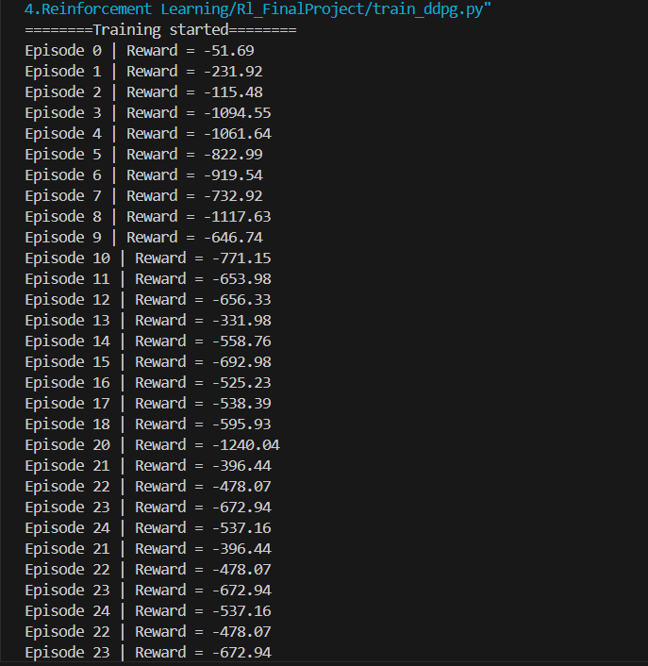
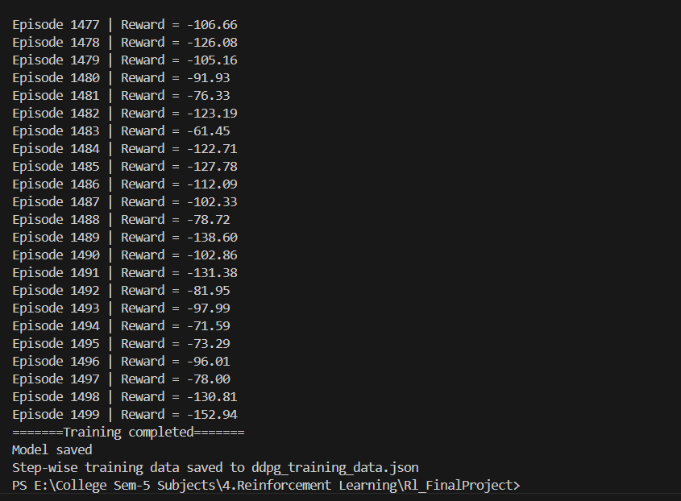

6. Hyperparameters
The following hyperparameters were selected to ensure smooth and stable learning in a continuous-action environment:
- Actor Learning Rate: 1e-4
Controls how fast the policy (action-selection network) updates. A smaller value prevents unstable sudden changes.
- Critic Learning Rate: 1e-3
Slightly higher because the Critic must learn more quickly to evaluate the policy’s actions accurately.
- Gamma (Discount Factor): 0.99
Places strong emphasis on long-term rewards, important for tasks like landing where early mistakes affect the final outcome.
- Tau (Soft Update Rate): 0.005
Used for slow updates to the target networks. This prevents instability and makes DDPG more reliable.
- Replay Buffer Size: 200,000
Large enough to store diverse experiences, helping the agent learn from many different states and situations.
- Batch Size: 256
A balanced batch size that allows stable gradient updates without excessive computational cost.
- Training Episodes: 1500
Providing enough time for the agent to explore, refine actions, and converge to a good landing strategy.
- Max Steps per Episode: 900
Ensures the agent has adequate time to stabilize and land the spacecraft in each episode.
- Action Noise: 0.1
Added during training to encourage exploration. Without noise, the agent might get stuck in a poor policy.

7. Results
7.1 Reward Curve
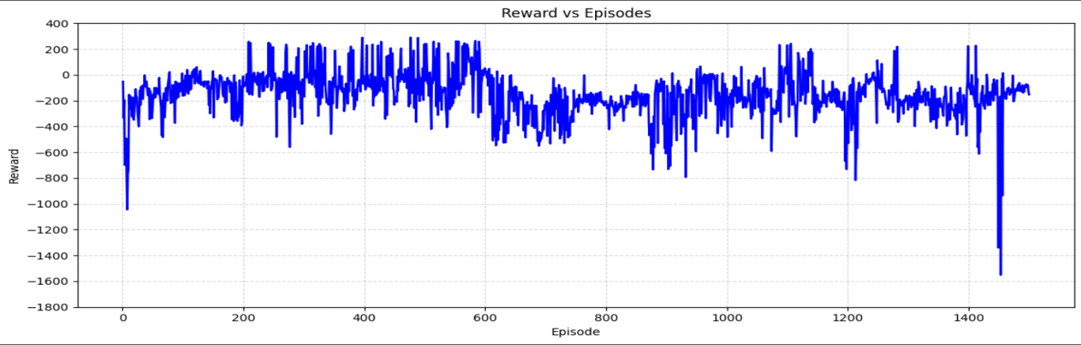
7.2 Lander Parameters (Continuous Behaviour)
The recorded parameters such as velocity, angle, angular velocity, and thrust values showed smooth continuous changes over each episode, which reflects the continuous-control nature of the DDPG algorithm.
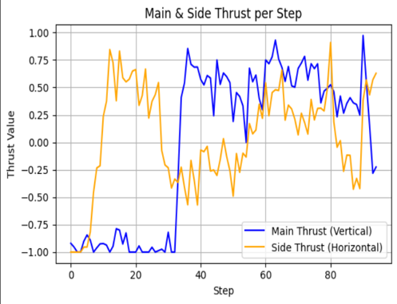
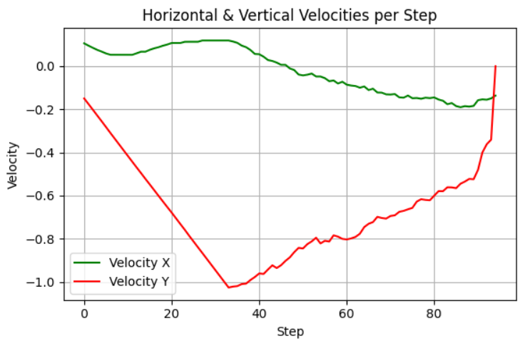
7.3 Visual Output
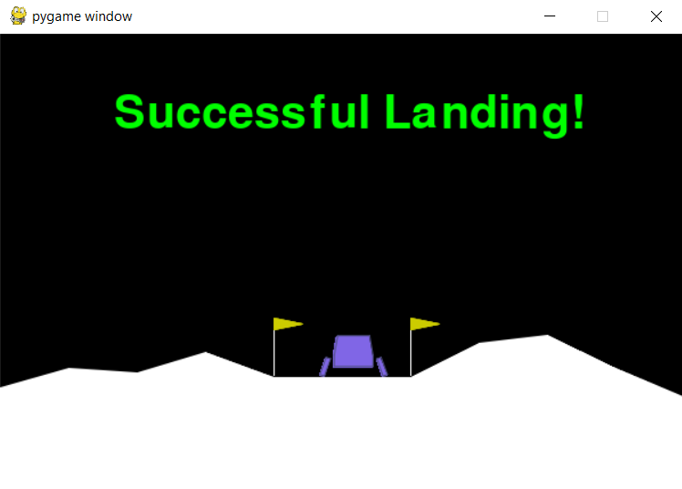

8. Discussion
8.1 Behaviour of the Agent
The trained agent learned to reduce speed before touchdown, stabilize its angle, and control side thrust effectively. Over time, it produced smoother trajectories and more controlled descent patterns.
8.2 Training Challenges
Training a continuous-action agent can be unstable, and the reward can fluctuate significantly. The agent initially struggled with high velocities and unstable angles and required many episodes before showing consistent improvements. Training DDPG presents several inherent issues. The algorithm is highly sensitive to hyperparameters, and even small changes can cause unstable learning. It also struggles with poor exploration in continuous action spaces, leading to slow improvement in early episodes. Additionally, DDPG often suffers from critic overestimation and fluctuating rewards, which makes training inconsistent and sometimes unstable.

8.3 Future Improvements
Performance can be improved by:
- Using TD3 instead of standard DDPG
- Adding prioritized replay
- Tuning noise decay for smoother exploration
- Increasing network size or changing activation functions

9.Conclusion
This project successfully demonstrated how the DDPG algorithm can be used to control the LunarLanderContinuous-v3 environment. Throughout 1500 episodes of training, the agent learned how to manage thrust, stabilize its angle, and perform smooth landings using continuous control. By using techniques like replay buffers, target networks, and soft updates, the training process became stable and effective.
The results showed steady improvement in the agent’s performance, with smoother trajectories and higher rewards over time. Visualization of rewards and flight parameters provided a clear understanding of how the agent progressed during learning.
Overall, this project helped us understand how reinforcement learning works in continuous action environments and how algorithms like DDPG can learn complex control behaviors. It also demonstrated the power of neural networks, exploration strategies, and environment feedback in building intelligent agents.

10.References
1. GeeksforGeeks — Reinforcement Learning Basics
https://www.geeksforgeeks.org/introduction-to-reinforcement-learning/
2. MathWorks — Deep Deterministic Policy Gradient (DDPG)
https://www.mathworks.com/help/reinforcement-learning/ug/train-ddpg-agent.html
3. Gymnasium Documentation — Box2D Lunar Lander (Continuous & Discrete)
Gymnasium. “Lunar Lander Environment (Box2D).”
https://gymnasium.farama.org/environments/box2d/lunar_lander/
4. OpenAI Gym Documentation — Continuous Action LunarLander
Gym Library. “Lunar Lander (Box2D) — Continuous Action Space.”
https://www.gymlibrary.dev/environments/box2d/lunar_lander/
5. Gymnasium Standard API Paper
https://eprints.soton.ac.uk/493069/1/2407.17032v1.pdf

